A REPORT ON THE PROJECT

CAMSHAFT AND CRANKSHAFT SYNCHRONISATION

submitted by

PEDDIREDDY SHRAVYA B80203097
PATIL SNEHA S . B80203091
TULE SHRADDHA Y . B80203135

in partial fulfillment for the award of the degree of

Bachelor of Engineering in ELECTRONICS AND TELECOMMUNICATION of UNIVERSITY OF PUNE,

under the guidance of
Prof. (Mr.) SACHIN A. PARANJAPE

Sponsored by : - COLLEGE (STATEMENT GIVEN BY KPIT CUMMINS LTD.)

M.K.S.S.S’s CUMMINS COLLEGE OF ENGINEERING FOR

WOMEN,KARVENAGAR ,PUNE – 411052 .

Academic year
2012 - 13

ACKNOWLEDGEMENT

We would like to express our sincere gratitude towards our internal guide Prof. (Mr.) Sachin A. Paranjape for the constant encouragement and valuable guidance during the completion of this project. We would also like to thank KPIT Cummins Ltd. for providing the problem statement for the project.
We would also like to thank Prof. Mr. S. V. Kulkarni (H.O.D E&TC) for his continuous valuable guidance, support, suggestions and his precious time in every possible way in spite of his busy schedule throughout the project activity.
We take this opportunity to express our sincere thanks to all the staff members of Electronics and Telecommunication Department for their help whenever required. Finally, we express our sincere thanks to all those who had helped us directly or indirectly in many ways in completion of this project work.

Student Names: Exam no:
Peddireddy Shravya B80203097
Patil Sneha Satish B80203091
Tule Shraddha Yuvraj B80203135

ABSTRACT
Engine performance of an automobile majorly depends upon the valve-train control mechanism used. In recent years, numerous valve-train control technologies have been developed and implemented, the camshaft (CAM) phasing system is one of them. This paper will describe the implementation of an electronically controlled CAM phasing system (ECCPS) to overcome the performance issues of the systems that are currently used for the same. The current CAM phasing systems are hydraulic or pneumatic based control systems whose performance is dependent on temperature and pressure of the fluid used. Though they are cheaper to implement, their dependency on environmental factors degrades their overall performance. The advantages of ECCPS phasing method include synchronization between the CAM and the crankshaft (CRANK) with higher precision, meeting the fuel economy standards and emission standards of internal combustion engines, reduction in hydrocarbon and NOx (Nitrogen Oxide and its derivatives) emissions, no mechanical wear and tear, improvement in engine torque leading to efficient performance.

TABLE OF CONTENTS
Introduction.........................................................................................................................9
Specifications....................................................................................................................10
- Internal Combustion Engine ....................................................................................12

1.1 Four-Stroke Engine...........................................................................12

- Need of Synchronization.........................................................................................14

- Need of Electronic CAM Phasing System................................................................14

- Present Trends........................................................................................................15

4.1 Electro-Mechanical Systems…………………………...................….15
4.2 Hydraulic Systems.............................................................................16
4.3 Stepper Motor Systems.....................................................................16
4.4 Pneumatic Systems…………………………………………............…17
- Working of the System.............................................................................................18

- Power Supply………………………………………………………………………….…21.

6.1 Power Supply Design………………………………………………….21

6.2 The reasons for choosing Bridge Rectifier…………………………..22

7. Microcontroller (MC9S08AC16A).............................................................................23

7.1 MC9S08AC16A Series Features......................................................23

8. BLDC (Brush-less DC) Motor...................................................................................27

8.1 More on Pole Pairs............................................................................30

8.2 Commutation Logic with Hall Sensor Inputs......................................31

8.3 Speed Control of Brush-less DC Motor.............................................33

8.3.1 Open Loop Speed Control.......................................33

8.3.2 Closed Loop Speed Control................................... 34

9. BLDC Switching Circuit Design...............................................................................34

9.1 IRS2003 MOSFET Driver..................................................................34

9.1.1 Features...................................................................35

9.2 IPB16CN10N Power MOSFET...........................................................35

9.2.1 Features...................................................................35

10. Hall-Effect Sensors.................................................................................................37

10.1 Basic Hall Effect Sensors...............................................................38

10.2 Digital Output Sensors....................................................................38

10.3 Hall Sensor (TLE4906K).................................................................39

10.3.1 Features.................................................................40

11. Simulation...............................................................................................................41

11.1 SolidWorks 2010.............................................................................41

11.2 Modelling Methodology...................................................................41

12. Mechanical Model...................................................................................................43

13. Test Results............................................................................................................44

13.1 Test Results of Simulation using SolidWorks.................................44

13.2 Test Results of Mechanical Model..................................................46

Discussion............................................................................................................................47
Conclusion...........................................................................................................................49

Future Work.........................................................................................................................50
References..........................................................................................................................51
LIST OF TABLES
Table.1. Drive Pattern for CW Direction........................................................................................32
Table.2. Drive Pattern for CCW Direction......................................................................................33

LIST OF FIGURES
Fig.1. Four Strokes in IC Engine....................................................................................................14
Fig.2. Camshaft with Valve-Train..................................................................................................15
Fig.3. Block Diagram Of the System.............................................................................................18
Fig.4. BLDC Motor........................................................................................................................19
Fig.5. Energizing the Stator Coils-1, 2, 3 for Clockwise rotation and 4, 5, 6 for Counter
Clockwise rotation..............................................................................................................19
Fig.6. Typical Hall-Effect Sensor...................................................................................................20
Fig.7. Power Supply.......................................................................................................................23
Fig.8. Block Diagram of Microcontroller.........................................................................................25

Fig.9. Pin Diagram of Microcontroller............................................................................................26

Fig.10. Step 1: Hall0 Sensor Outputs “1”; Resultant Pattern is 001 [Hall2:Hall1:Hall0]..............28
Fig.11.Step2:Hall0 Hall1 Sensor Outputs “1”; Resultant Pattern is 011 [Hall2:Hall1:Hall0].. ....28
Fig.12. Step 3: Hall1 Sensor Outputs “1”; Resultant Pattern is 010 [Hall2:Hall1:Hall0]..............28
Fig.13. Step 4: Hall1 Hall2 Sensor Outputs “1”; Resultant Pattern is 110 [Hall2:Hall1:Hall0]...29
Fig.14. Step 5: Hall2 Sensor Outputs “1”; Resultant Pattern is 100 [Hall2:Hall1:Hall0]..............29
Fig.15. Step 6: Hall2 Hall0 Sensor Outputs “1”; Resultant Pattern is 101 [Hall2:Hall1:Hall0]...29
Fig.16. Output of Hall Sensors......................................................................................................30
Fig.17. Single Pole Pair and Two Pole Pair Motors......................................................................31
Fig.18. Commutation Logic with Hall Sensor Inputs.....................................................................32
Fig.19. Open Loop Speed Control................................................................................................33
Fig.20. Closed Loop Speed Control.............................................................................................34
Fig.21. Interfacing MOSFETs with IRS2003................................................................................34
Fig.22. IRS2003 IC......................................................................................................................35
Fig.23. IPB16CN10N IC...............................................................................................................35
Fig.24 BLDC Motor Driving Circuitry............................................................................................36
Fig.25 Current Distribution in Hall-Sensor....................................................................................37
Fig.26 Hall-Effect Sensor with Signal Conditioning......................................................................38

Fig.27 Digital Output Hall-Effect Sensor......................................................................................39

Fig.28. Hall-Sensor IC..................................................................................................................40

Fig.29. Piston Head modelled using Solidworks..........................................................................41

Fig.30. Connecting Rod using Solidworks...................................................................................41
Fig.31. Engine Body....................................................................................................................42
Fig.32. Spark Plug.......................................................................................................................42
Fig.33. Model of the system in Solidworks..................................................................................44
Fig.34. Angular Velocity of the Crankshaft..................................................................................44
Fig.35. Angular Velocity of the Camshaft....................................................................................45
Fig.36. Translational Displacement of the Piston........................................................................45
Fig.37. CM Position Displacement of the Piston.........................................................................45
Fig.38. Translational Displacement of the Inlet Valve.................................................................45
Fig.39. Translational Displacement of the Outlet Valve..............................................................46
Fig.40. HyperTerminal Window indicating the rpm
(B: rpm of BLDC Motor, E: rpm of DC Motor)................................................................46

LIST OF ABBREVIATIONS

CAM: Camshaft
CRANK: Crankshaft
NOx: Nitrogen Oxide and its Derivatives
ECCPS: Electronically Controlled CAM Phasing System
EGR: Exhaust Gas Recirculation
RPM: Revolutions per minute
BLDC Motor: Brushless DC Motor
HES: Hall-Effect Sensors
PMDC Motor: Permanent Magnet DC Motor
EMI: Electromagnetic Interference
MOSFET: Metal Oxide Semiconductor Field Effect Transistors
ADC: Analog to Digital Convertor
CPU: Central Processing Unit

INTRODUCTION
The basis of these technologies is to control the angular position of the Camshaft (CAM) relative to the position of the Crankshaft (CRANK), resulting in maximum attainable synchronization between their relative motion. This CAM phasing method (changing the angular position of CAM) has proved effective as compared to other methods because it is simpler to implement
The present day automobiles are utilizing diverse technologies for implementing CAM phasing, which are either mechanical, hydraulic or pneumatic based systems. A typical mechanical system utilizes gear-chain/timing-belt mechanism to attain CAM phasing through synchronization between CAM and CRANK i.e. changing the angular position of CAM with respect to CRANK. But this system suffers from high mechanical wear and tear leading to loss in synchronization and poor engine efficiency.
The hydraulic and pneumatic systems control CAM phasing through internal vane mechanism operated by high pressure flow of the fluid used. Though these systems are cheap and mechanically robust, their dependence on environmental conditions makes them less reliable and more prone to errors.
The ECCPS demonstrates superior engine performance and efficient control over CAM phasing as compared to currently used systems. Moreover, by using an electronically controlled system, variable CAM phasing, reduction of load on CRANK, better engine power utilization and elimination of Exhaust gas recirculation (EGR) systems is also possible.
The ECCPS uses a 3-phase Brushless DC Motor (BLDC) mechanically coupled to the CAM. The BLDC motor has its own control unit, and is responsible for actuating the CAM. The position of the CAM and CRANK is monitored using a master Microcontroller, which maintains the synchronization between CAM and CRANK by regularly polling their angular position. The positional information of the shafts is obtained using Hall Effect Sensors (HES) and accordingly the speed of CAM is adjusted to maintain efficient valve-train control.
In totality, ECCPS continuously monitors CAM & CRANK phase angles, calculates the phase angle error if present, and varies the BLDC motor 3-phase currents accordingly to achieve synchronisation between CAM & CRANK.

SPECIFICATIONS
The aim of this project is to test the ECCPS on 90 cc, Single Cylinder, 4-Stroke Engine. The major specifications used for developing the Virtual Model using SolidWorks 2010 are as follows:
Dimensions:
Length | 1735 mm
Width | 657 mm
Height | 1065 mm
Engine Specifications:
Engine Type | 4-Stroke Single Cylinder
Displacement | 87.8 cc
Maximum Power | 5.0@6500 BHP@RPM
Maximum Torque | 5.8@4000 Nm@rpm
Bore | 51 mm
Stroke | 43 mm
Compression Ratio | 10.0:1

For the Mechanical Model also, the above mentioned specifications have been used.
For the implementation of ECCPS, BLDC Motor is required. The specifications for the BLDC Motor controller circuitry are as follows:
MOSFET Driver Specifications:

- VOFFSET between 0V to 200 V max.
- IO+/- 130 mA/270 mA
- VOUT 10 V - 20 V
- ton/off (typ.) 680 ns/150 ns
- Dead-time (typ.) 520 ns
IRS2003 MOSFET Driver matches the required specifications.

Power MOSFET Specifications:

- Vds 100V
- Rds (on) 16 mΩ
- Id(25ْ) 53 A
- Id(pulsed) 212A

IPB16CN10N Power MOSFET satisfies the required Specifications.

The ECCPS requires an 8-bit automotive-grade Microcontroller with high frequency of operation and tolerance to high temperatures. It should possess internal ADC and Serial communication capabilities. The following are the major specifications for the Microcontroller:
- Supply voltage VDD –0.3 to + 5.8 V
- Input voltage Vin – 0.3 to VDD+0.3V
- Instantaneous maximum current Single ID ± 25 mA
pin limit (applies to all port pins)
- Maximum current into VDD IDD 120 mA
- Storage temperature Tstg –55 to +150 °C

MC9S08AW16A satisfies the required specifications.

1. INTERNAL CUMBUSION ENGINE
The internal combustion engines convert the chemical energy available in fuel into mechanical energy. This mechanical energy moves pistons up and down inside cylinders. The pistons are connected to a crankshaft, and the up-and-down motion of the pistons, known as linear motion, creates the rotary motion needed to turn the wheels of a car forward. The diesel engines covert fuel into energy through a series of small explosions or combustions. In a diesel engine, the combustion mixture is prepared by mixing compressed air with injected fuel in a definite proportion. Because air heats up when it's compressed, the fuel ignites.
1.1 FOUR STROKE ENGINE
A four-stroke internal combustion engines have four basic steps that repeat with every two revolutions of the engine:
(1) Intake stroke (2) Compression stroke (3) Power stroke and (4) Exhaust stroke
1. Intake stroke: The first stroke of the internal combustion engine is also known as the suction stroke because the piston moves to the maximum volume position (downward direction in the cylinder). The inlet valve opens as a result of the cam lobe pressing down on the valve stem, and the vaporized fuel mixture enters the combustion chamber. The inlet valve closes at the end of this stroke.
2. Compression stroke: In this stroke, both valves are closed and the piston starts its movement to the minimum volume position (upward direction in the cylinder) and compresses the fuel mixture. During the compression process, pressure, temperature and the density of the fuel mixture increases.
3. A Power stroke: When the piston reaches a point just before top dead center, the spark plug ignites the fuel mixture. The point at which the fuel ignites varies by engine; typically it is about 10 degrees before top dead centre. This expansion of gases caused by ignition of the fuel produces the power that is transmitted to the crank shaft mechanism.
4. Exhaust stroke: In the end of the power stroke, the exhaust valve opens. During this stroke, the piston starts its movement in the maximum volume position. The open exhaust valve allows the exhaust gases to escape the cylinder. At the end of this stroke, the exhaust valve closes, the inlet valve opens, and the sequence repeats in the next cycle. Four-stroke engines require two revolutions. The working can be understood better by observing Figure 1.
Fig.1. Four-strokes in an IC Engine

2. NEED OF SYNCHRONIZATION
The engine valve-train consists of intake valves, exhaust valves and a mechanism that opens and closes them as shown in Fig. 2.

Fig.2. Camshaft with Valve-train

The CAM has lobes (called as cams) which drive the valve-train resulting in opening and closing of these valves for fuel intake and exhaust release, as the CAM rotates. The CAM has to rotate at one-half the rate of the CRANK in order to complete one engine cycle. This inter-dependence of rotation of CAM relative to CRANK’s rotation is called Camshaft and Crankshaft Synchronization. Synchronization is essential for broadening the engine torque, increasing peak power at higher RPM (revolutions per minute), reducing un-burnt hydrocarbon (HC) and NOx emissions and improving fuel efficiency.
3. NEED OF ELECTRONIC CAM PHASING
One of the major advantages of using Electronic CAM Phasing system is that it controls the angular position of the CAM relative to the crankshaft allowing changes to the timing of valve lift events. This method has advantages including broadening the engine torque curve, increasing peak power at higher RPM, reducing hydrocarbon and NOx emissions, and improving fuel economy.
Current implementations of CAM phasing are divided into two major types, namely Mechanical Based and Hydraulic Based. The Mechanical based systems utilize either an extensive Gear Mechanism or Implement Timing Belt Mechanism whereas, the Hydraulic systems use oil-pressure to control the Vane-type rotor, which act as an actuator to control the Cam Phasing. While these systems are relatively low cost and have proven to be robust, they have disadvantages at low oil temperatures and pressures. To overcome performance issues of oil based systems, phasing system independent of oil conditions is needed.
The ECCPS can successfully overcome the above mentioned limitations.
4. PRESENT TRENDS
The current systems used for CAM Phasing not only control the CAM motion but also implement Variable Valve Timing Principle. In internal combustion engines, Variable valve timing (VVT), also known as Variable valve actuation (VVA), is any mechanism or method that can alter the shape or timing of a valve lift event within an internal combustion engine. VVT allows the lift, duration, or timing (in various combinations) of the intake and/or exhaust valves to be changed while the engine is in operation. There are many ways in which this can be achieved, ranging from mechanical devices to electro-hydraulic and cam-less systems. The current technologies use for CAM Phasing along with VVT are as follows:

4.1 Electro-Mechanical
This method of valve control is often found in cam-less engine designs. In this design the valves are opened and closed and held open or closed by means of electromagnets. Some of the problems which may be encountered with this methodology are:
- Deceleration of the valve once set in motion is difficult to accomplish. This difficulty is exacerbated by the greatly increased magnetic pull of the magnets as the valves approach the end of their travel (magnetic pull increases dramatically as the distance from the magnet decreases). Inadequate slowing down of the valve can cause significant deterioration of the valve seat and other parts. Utilizing springs to effect valve deceleration limits the engine to lower speeds and on its own will not effect a gentle landing of the valve on its seat at all engine speeds.
- Springs utilized in this type of system may require very careful balancing with the valve movement in order to achieve gentle valve seating at differing engine speeds. As the springs deteriorate or the engine speed changes, the valve and spring balance may be compromised and ultimately lead to failure.
- The electromagnets will draw a significant amount of electrical energy, which may require a higher capacity alternator, which will in turn reduce the potential fuel efficiency of the engine, though other sources of battery recharging such as regenerative braking may help in a more fuel-efficient manner.
- A powerful computer coupled with complex fast-acting control circuitry and devices will likely be necessary to control the valves in real time.

4.2 Hydraulic
This type of valve control has been advocated in the search for a cam-less engine. Various methods have been explored to utilize hydraulic mechanisms to move the engine valves. Some claim to be successful at low engine speeds, but few claim to achieve that goal meaningfully at the higher RPM requirements of passenger vehicles.
Hydraulic systems suffer from two inherent problems:
- The faster a liquid is moved, the more it tends to act like a solid. A fast-acting hydraulic system to activate automotive valves at the speeds required in passenger vehicles could require immense pressures, with all the incumbent problems, including the additional energy requirements of the hydraulic pump. Even if higher engine speeds were achieved, valve movement would likely be abbreviated and not fully follow the desired or optimum lift schedule.
- Temperatures can vary seasonally over a wide range. The hydraulic medium could change viscosity as the temperatures change, which could cause variances in the system's performance which may be difficult to control.
Utilizing springs to assist the hydraulic system may also prevent the engine attaining higher speeds. In order to achieve gentle valve seating, hydraulic systems must be carefully controlled. This control may require the use of powerful computers and very precise sensors.

4.3 Stepper Motors
This methodology of valve control has previously not been successful in cam-less engine design due to the limited RPM range inherent in the design. Valves that open and close in fixed times cannot optimize engines running at differing speeds and importantly severely restrict engine speed. This is because the degrees of rotation for the valve events increase as the engine speed increases to the point where they are no longer practical.
The engine may be able to run at higher RPM by limiting the lift and hence shortening the valve open close time but will most likely have a lower power output than is achieved at a lower RPM due to the lessening of breathing capability.

4.4 Pneumatic
Systems utilizing pneumatics to drive the engine valves are feasible but have proved impossible for practical utilization because of their complexity and the very large amount of energy required for compressing the air.

5. WORKING OF THE SYSTEM
As mentioned earlier, the ECCPS consists of a BLDC motor mechanically coupled to the CAM, a motor control unit along with a master Microcontroller and HES. The block diagram of the system is shown in Fig. 3.
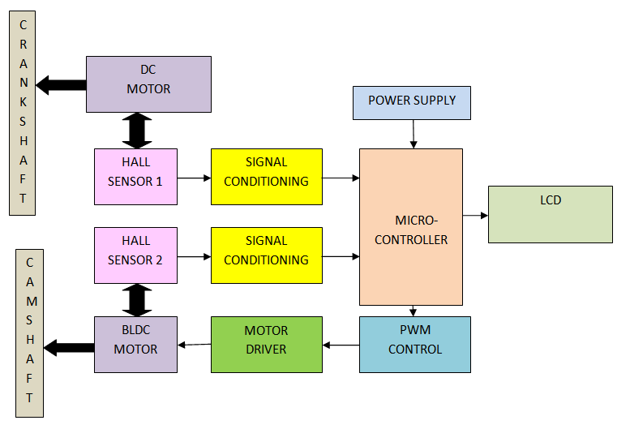
Fig.3. Block diagram of the system
ECCPS essentially maintains the synchronization between the motion of CAM and CRANK by controlling the angular position of the CAM with the actuation of BLDC motor relative to the angular position of the CRANK.
The use of BLDC motor for actuating the CAM is advantageous because it is more reliable, clean and a quieter alternative to AC or Permanent Magnet DC motors. The BLDC motor provides more torque per weight, superior efficiency, reduced noise, longer lifetime (since there is no brush and commutator erosion), elimination of ionizing sparks from the commutator, and overall reduction of electromagnetic interference (EMI). A typical BLDC motor is shown in Fig. 4. The BLDC motor is a hybrid of the AC and DC motors whose rotor has permanent magnets and stator has windings.

Fig.4. BLDC Motor
The BLDC motor is interfaced to the motor control unit which is responsible for controlling the various parameters of motor rotation such as speed, phase angle etc. The control unit typically consists of a 3-phase MOSFET (Metal Oxide Semiconductor Field Effect Transistor) bridge driver circuitry which is used for driving the motor. The driver circuitry consists of a pair of MOSFETs for each stator winding. These MOSFETs act as switches. In order to drive the rotor, its stator windings are energized by switching each pair of MOSFETs sequentially according to the current position of rotor. The position of the rotor is sensed by HES to bring about its motion. By energizing specific stator windings, a revolving magnetic field is generated. At this precise instant, current is switched to the next winding. By switching current to the windings in a pre-determined sequence, the permanent magnets on the rotor attempt to chase the current.
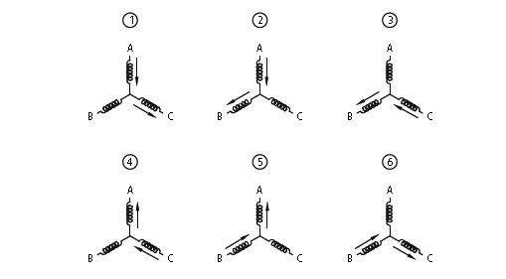
The current is always switched before the permanent magnets catch up. Therefore, the speed of the motor is directly proportional to the current switching rate. At any instant, two windings are energized with the third one off. This combines the torques of two phases at one time, thus increasing the overall torque output of the motor. The direction of rotation of the rotor is determined by the sequence in which each stator winding is energized. Fig. 5. shows the energizing sequence of the stator windings for clockwise and counter-clockwise rotation of the motor.

Fig.5. Energizing the stator coils-1, 2, 3 For Clockwise Rotation and 4, 5, 6 For Counter-Clockwise Rotation
The position of the rotor is continuously monitored using Hall-Effect Sensors. The HES are electromagnetic devices which produce a pulse train-like voltage-output signal governed by the time-varying fluctuations of magnetic flux created by rotating motion of mechanical parts. In order to monitor the position of the CRANK, a disc with magnets is mounted on it. As the teeth rotate with the shaft and pass by the sensor; flux variations are generated in the sensor’s magnetic circuit. Via Faraday’s law, the sensor generates voltage variations in its sensing coil which corresponds to the derivative of magnetic flux with respect to time. As a result a constant current flows through it, the perpendicular voltage over the same metal changes with the variation in strength of the applied magnetic field. A typical hall-effect sensor is shown in Fig. 6. The advantage of these sensors is that they feature low cost, small-to-moderate size, self-generated signals, and good temperature stability. The HES also have the advantage of being insensitive to dust, humidity, vibration and have a constant behaviour over time.
The feedback from these sensors is used to energize the stator windings. Typically for a 3-phase BLDC motor, three HES placed 120˚ degrees apart, placed at close proximity of the CAM are utilized to monitor its position. Similarly the position of the CRANK is also monitored using HES.
Fig.6. Typical Hall-Effect Sensor
These HES are interfaced to the microcontroller through signal conditioning circuitry in order to eliminate noise and amplify the received signals from the sensors to required voltage level so that they are efficiently utilized by the microcontroller. The microcontroller is responsible for calculating the desired position of the shafts and energizing the required stator winding, which rotates the CAM as per the required position with respect to CRANK. An automotive 8-bit microcontroller with inbuilt ADC (Analog to Digital Convertor) and a CPU (Central Processing Unit) having high frequency of operation is used in the system.
Hence, a completely electronic system can be used for CAM phasing for superior control of engine valve-train events, which in turn enhances engine performance.
6. POWER SUPPLY

The basic step in the designing of any system is to design the power supply required for that system. The steps involved in the designing of the power supply are as follows,
1) Determine the total current that the system sinks from the supply.
2) Determine the voltage rating required for the different components.

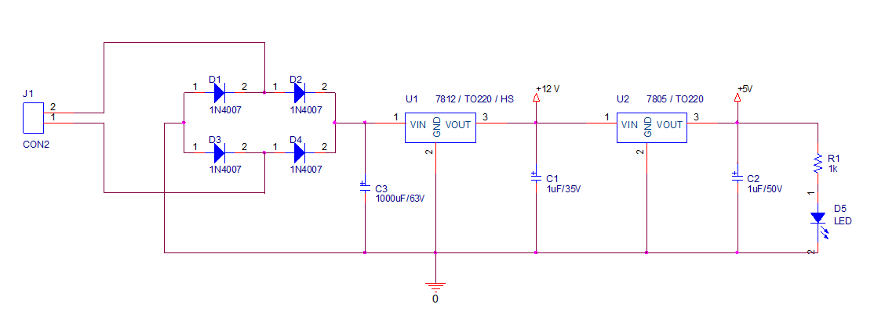
Fig.7. Power Supply
The bridge rectifier and capacitor i/p filter produce an unregulated DC voltage which is applied at the I/P of 7812 and then to 7805.As the minimum dropout voltage is 2V for IC 7812 and 7805, the voltage applied at the input terminal should be at least 14 for IC 7812 and 7 volts for IC 7805 .
C1 (1000 µf / 63V) is the filter capacitor and C2 and C3 (0.1 uf) is to be connected across the regulator to improve the transient response of the regulator.

6.1 Power Supply Design:

The average voltage at the output of a bridge rectifier capacitor filter combination is given by,

Vin(DC) = Vm – Idc / 4 f C1

Where, Vm=√2 Vs and Vs = rms secondary voltage

Assuming Idc to be equal to maximum load current, say 100mA

C = 1000 uf / 63v , f=50hHz

19 = Vm – 0.1*10⁻⁶ / 4*50*1000*10⁻⁶
19= Vm – 0.1 / 0.2
Vm=19.5 volts

Hence the RMS secondary Voltage

Vrms = vm / √2
= 19.5 / √2
=19,5 / 1.4142
=13.5 volts
So we can select a 15v secondary Voltage
In our system most of the components used require 5 V as operating voltage such as micro controller. The total current, which our circuit sinks from the power supply, is not more than 100 mA. We have used Regulator IC 7812 and IC 7805 that gives output voltage of 12 v and 5V respectively. The minimum input voltage required for the7812 is 14 V and for 7805 is about7 v. Therefore we have used the transformer with the voltage rating 230v-10v and current rating 500 mA. The output of the transformer is 12 V AC. This Ac voltage is converted into 12 V DC by Bridge rectifier circuit.

6.2 The reasons for choosing the Bridge Rectifier:

- The TUF is increased to 0.812 as compared the full wave rectifier.
- The PIV across each diode is the peak voltage across the load = V_{m} , not 2V_{m} as in the two diode rectifier
Output of the bridge rectifier is not pure DC and contains some AC ripples in it. To remove these ripples we have used capacitive filter, which smoothens the rippled output that we apply to7812 and 7805 regulators IC that gives 12 V and 5V DC respectively. We preferred to choose capacitor filters since it is cost effective, readily available and not too bulky.
7. MICROCONTROLLER (MC9S08AC16A)
The MC9S08AC16 Series devices are members of the low-cost, high-performance HCS08 Family of 8-bit microcontroller units (MCUs). All MCUs in the family use the enhanced HCS08 core and are available with a variety of modules, memory sizes, memory types, and package types memory sizes and package types. The MC9S08AW16A and MC9S08AW8A devices are qualified for, and are intended to be used in, automotive applications.

7.1 MC9S08AC16A Series Features

8-Bit HCS08 Central Processor Unit (CPU)
• 40-MHz HCS08 CPU (central processor unit)
• 20-MHz internal bus frequency
• HC08 instruction set with added BGND
Instruction
• Background debugging system
• Breakpoint capability to allow single breakpoint setting during in-circuit debugging (plus two more breakpoints in on-chip debug module)
• Debug module containing two comparators and nine trigger modes. Eight deep FIFO for storing change-of-flow addresses and event-only data.Debug module supports both tag and force breakpoints.
• Support for up to 32 interrupt/reset sources
Memory Options
• Up to 16 KB of on-chip in-circuit programmable FLASH memory with block protection and security options
• Up to 1 KB of on-chip RAM Clock Source Options
• Clock source options include crystal, resonator, external clock, or internally generated clock
with precision NVM trimming
System Protection
• Optional computer operating properly (COP) reset with option to run from independent
internal clock source or bus clock
• Low-voltage detection with reset or interrupt
• Illegal opcode detection with reset
• Illegal address detection with reset Power-Saving Modes. Wait plus two stops

Peripherals
• ADC — 8-channel, 10-bit analog-to-digital converter with automatic compare function
• SCI — Two serial communications interface modules with optional 13-bit break
• SPI — Serial peripheral interface module
• IIC — Inter-integrated circuit bus module to operate at up to 100 kbps with maximum bus
loading; capable of higher baud rates with reduced loading • Timers — Three 16-bit timer/pulse-width modulator (TPM) modules — Two 2-channel and one 4-channel; each has selectable input capture, output compare, and edge-aligned PWM capability on each channel. Each timer module may be configured for buffered, centered PWM (CPWM) on all channels
• KBI — 7-pin keyboard interrupt module Input/Output
• Up to 38 general-purpose input/output (I/O) pins
• Software selectable pullups on ports when used as inputs
• Software selectable slew rate control on ports when used as outputs
• Software selectable drive strength on ports when used as outputs
• Master reset pin and power-on reset (POR)
• Internal pull-up on RESET, IRQ, and BKGD/MS pins to reduce customer system cost
Package Options
• 48-pin quad flat no-lead package (QFN)
• 44-pin low-profile quad flat package (LQFP)*
• 42-pin shrink dual-in-line package (SDIP)
• 32-pin low-profile quad flat package

The block diagram shows the structure of the MC9S08AC16 Series MCU.
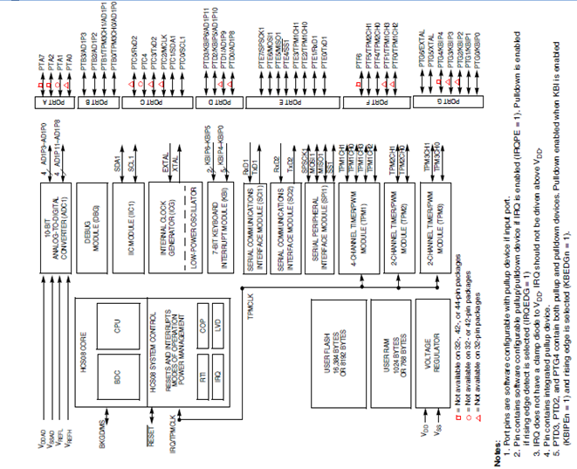
Fig.8. Block Diagram of Microcontroller
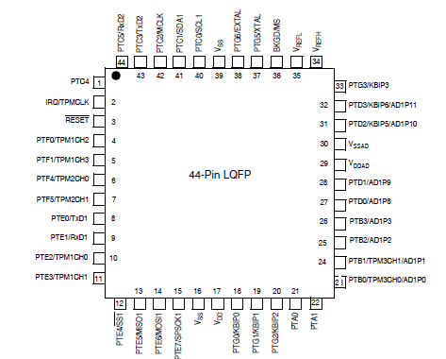
Fig.9. Pin Diagram of Microcontroller

8. BLDC (Brush-less DC) MOTOR
Brushless DC Motor or the BLDC Motor is a rotating electric motor consisting of stator armature windings and rotor permanent magnets whereas in a conventional brushed DC motor the stator is made up of permanent magnets and rotor consists of armature windings. The conventional DC motor commutes itself with the use of a mechanical commutator whereas brushless DC motor needs electronic commutation for the control of current direction through the windings. Typically BLDC motors have three phase windings that are wound in star or delta fashion and need a three phase inverter bridge for the electronic commutation.
In BLDC motors the phase windings are distributed in trapezoidal fashion in order to generate the trapezoidal BEMF waveform. The commutation technique generally used is trapezoidal or called block commutation where only two phases will be conducting at any given point of time. An alternative way of commutating the motor is called sinusoidal commutation in which all the three phases will be conducting at any given point of time. PMSM motors also interchangeably called as BLDC motors which have the windings distributed in sinusoidal fashion suited for this sinusoidal type of commutation. The torque generated by PMSM motors is smooth as compared to BLDC motors in which torque will have more ripples. But the peak torque developed by PMSM motors is less as compared to BLDC motors.
The trapezoidal commutation method is the simplest way to control BLDC motors and easy to implement the control aspects of it. For proper commutation and for motor rotation, the rotor position information is very crucial. Only with the help of rotor position information, the electronic switches in the inverter bridge will be switched ON and OFF to ensure proper direction of current flow in respective coils. Hall effect sensors [Hall2, Hall1, Hall0] are used in general as position sensors for trapezoidal commutation. Each hall sensor is typically placed 120 degrees apart and produces “1‟ whenever it faces the North Pole of the rotor. The hall sensor patterns for a single pole pair BLDC motor during its 360 degree of rotation is shown in the following figures below. The hall sensor shown in red indicates that it outputs “1”.

Fig.10. Step 1: Hall0 Sensor Outputs “1”; Resultant Pattern is 001 [Hall2:Hall1:Hall0]

Fig.11. Step 2: Hall0 and Hall1 Sensors Output “1”; Resultant Pattern is 011 [Hall2:Hall1:Hall0]

Fig.12. Step 3: Hall1 Sensor Outputs “1”; Resultant Pattern is 010 [Hall2:Hall1:Hall0]

Fig.13. Step 4: Hall1 and Hall2 Sensors Output “1”; Resultant Pattern is 110 [Hall2:Hall1:Hall0]
Fig.14. Step 5: Hall2 Sensor Outputs “1”; Resultant Pattern is 100 [Hall2:Hall1:Hall0]

Fig.15. Step 6: Hall2 and Hall0 Sensors Output „1‟; Resultant Pattern is 101 [Hall2:Hall1:Hall0]

8.1 MORE ON POLE PAIRS
For motors with any number of pole pairs, for each electrical revolution we get six hall patterns as shown in Fig. 16.
Fig.16. Output of Hall Sensors
But the number of mechanical revolution depends on the number of pole pairs of rotor. For a motor with a single pole pair, the number of mechanical and electrical revolution are equal and hence the electrical angle and mechanical angle. But for a motor with more than one pole pairs, the number of mechanical and electrical revolutions is not equal. The relationship can be described with the following equation:
Number of electrical revolutions = Pole pairs * Number of mechanical revolution
Therefore, Electrical angle = Pole pairs * Mechanical angle
Fig.17. Single Pole Pair and Two Pole Pair Motors
As the number of pole-pairs increase with the motor, more electrical revolutions occur, Hall pattern changes will be faster, and commutation changes will also be faster. For higher speed operations this necessitates for higher PWM Frequency to achieve good precision control.
Brushless DC (BLDC) motors are rapidly gaining popularity. They offer longer life and less maintenance than conventional brushed motors. Some other advantages over brushed DC motors and induction motors are: better speed versus torque characteristics, noiseless operation and higher speed ranges. And in addition, the ratio of torque delivered to the size of the motor is higher, making them useful in applications where space and weight are critical factors. The electromagnets do not move; instead, the permanent magnets rotate and the phase stator windings remain static
The speed and torque of the motor depend on the strength of the magnetic field generated by the energized windings of the motor, which depend on the current through them. Therefore adjusting the rotor voltage (and current) will change the motor speed.
8.2 Commutation Logic with Hall Sensor Inputs
Note that on every Hall event, only one bit changes. The motor datasheet from the manufacturer specifies the Hall pattern for the CW and CCW direction of rotation and the corresponding coils that need to be energized.
Energizing the appropriate phase coils based on the Hall sensor inputs is known as commutation logic. Whenever a new Hall signal change is detected, the new drive switching pattern is applied. Figure 10 shows the motor current direction through the windings when they are energized, based on the Hall pattern, and is represented as numbers from 1, 2, 3, 4, 5, and 6.
Fig.18. Commutation Logic with Hall Sensor Inputs
The following table lists the details on the power device switching sequence for a given Hall signal pattern to rotate in clockwise (CW) direction. This table is applicable for the default motor which is shipped with the kit. The switching states “1” and “0” represent the ON and OFF conditions of the switches.
Table.1. Drive Pattern for CW Direction
Hall3 (H3) | Hall2 (H2) | Hall1 (H1) | PWM C High | PWM C Low | PWM B High | PWM B Low | PWM A High | PWM A Low
1 | 0 | 1 | 0 | 1 | 0 | 0 | 1 | 0
1 | 0 | 0 | 1 | 0 | 0 | 0 | 0 | 1
1 | 1 | 0 | 1 | 0 | 0 | 1 | 0 | 0
0 | 1 | 0 | 0 | 1 | 1 | 0 | 0 | 0
0 | 1 | 1 | 0 | 0 | 1 | 0 | 0 | 1
0 | 0 | 1 | 0 | 0 | 0 | 1 | 1 | 0

The following table gives the drive switching pattern for running the motor in counter clockwise direction. Please note that for CCW direction, the bits of the High-side and Low-side bits which drive each phase winding are just swapped to arrive at the drive switching pattern.

Table.2. Drive Pattern for CCW Direction
Hall3 (H3) | Hall2 (H2) | Hall1 (H1) | PWM C High | PWM C Low | PWM B High | PWM B Low | PWM A High | PWM A Low
1 | 0 | 1 | 1 | 0 | 0 | 0 | 0 | 1
1 | 0 | 0 | 0 | 1 | 0 | 0 | 1 | 0
1 | 1 | 0 | 0 | 1 | 1 | 0 | 0 | 0
0 | 1 | 0 | 1 | 0 | 0 | 1 | 0 | 0
0 | 1 | 1 | 0 | 0 | 0 | 1 | 1 | 0
0 | 0 | 1 | 0 | 0 | 1 | 0 | 0 | 1

8.3 Speed Control of Brushless DC Motor
The speed of the BLDC motor is directly proportional to the applied voltage. The commutation logic specifies the coils that need to be energized for every 60 degree of electrical revolution based on Hall inputs. The Pulse Width Modulation logic specifies the time intervals during which the switches should be ON and OFF to average the DC Bus voltage applied thereby controlling the Speed. If the switches are ON for the complete duration of the commutation period, then the DC bus rated voltage is directly fed to the phase windings of the motor. Hence the motor will run at the rated speed as specified in the motor datasheet. To operate at any speed below this level, the commutation pattern applied at either the High-side or Low-side switch should be pulse-width modulated with the PWM Pulses at a specified frequency, called the PWM Frequency.
8.3.1 Open Loop Speed Control
In open loop speed control, the duty cycle is directly calculated from the set reference speed and there is no actual speed feedback for control purpose.
Fig.19. Open Loop Speed Control
8.3.2 Closed Loop Speed Control
In closed loop speed control, the set speed and the actual speed are compared and the error is fed to the PI controller, which finally outputs the required duty cycle in order to achieve the required speed operation of the motor.
Fig.20. Closed Loop Speed Control
9. BLDC SWITCHING CIRCUIT DESIGN
For implementing the BLDC switching circuitry IRS2003 MOSFET Driver and IPB16CN10N Power MOSFET have been used.

9.1 IRS2003 MOSFET DRIVER

The IRS2003 is a high voltage, high speed power MOSFET and IGBT drivers with dependent high- and low-side referenced output channels. Proprietary HVIC and latch immune CMOS technologies enable ruggedized monolithic construction. The logic input is compatible with standard CMOS or LSTTL output, down to 3.3V logic. The output drivers feature a high pulse current buffer stage designed for minimum driver cross conduction. The floating channel can be used to drive an N-channel power MOSFET or IGBT in the high-side configuration which operates up to 200 V.
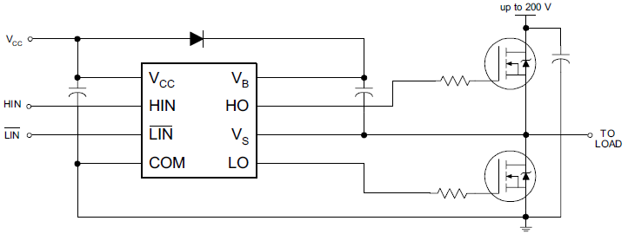
Fig.21. Interfacing MOSFETs with IRS2003

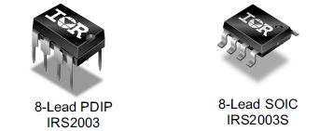

Fig.22. IRS2003 IC
9.1.1 FEATURES

- Floating channel designed for bootstrap operation
- Fully operational to +200 V
- Tolerant to negative transient voltage, dV/dt immune
- Gate drive supply range from 10 V to 20 V
- Under-voltage lockout
- 3.3 V, 5 V, and 15 V logic compatible
- Cross-conduction prevention logic
- Matched propagation delay for both channels
- Internal set dead time
- High-side output in phase with HIN input
- Low-side output out of phase with LIN bar input
- RoHS compliant

9.2 IPB16CN10N POWER MOSFET

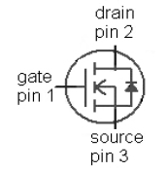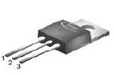
Fig.23. IPB16CN10N IC

9.2.1 FEATURES

- N-Channel, normal level
- Excellent gate charge xR_{DS(on)} product (FOM)
- Very low on-resistance R_{DS(on)}
- 175C operating temperature
- Pb-free plating; RoHS compliant
- Qualified according to JEDEC for target application
- Ideal for high-frequency switching and synchronous rectification
- Halogen-free
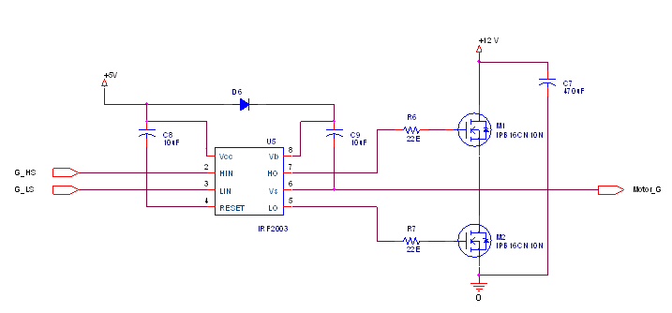
Fig.24. BLDC Motor Driving Circuitry

Instantaneous maximum single pin current of the microcontroller is 25mA at 5V which is obviously not sufficient to drive the MOSFETs. Hence, the output from microcontroller is connected to the MOSFET Driver which gives the output voltage in the range of 10 – 20 V. The output of the MOSFET for 12V high side supply voltage is 212A which is sufficient to drive the BLDC motor.

10. HALL EFFECT SENSOR
When a current-carrying conductor is placed into a magnetic field, a voltage will be generated perpendicular to both the current and the field. This principle is known as the Hall effect. Fig. 25. illustrates the basic principle of the Hall Effect. It shows a thin sheet of semiconducting material (Hall element) through which a current is passed. The output connections are perpendicular to the direction of current. When no magnetic field is present (Fig. 21.), current distribution is uniform and no potential difference is seen across the output. When a perpendicular magnetic field is present, as shown in Fig. 25., a Lorentz force is exerted on the current. This force disturbs the current distribution, resulting in a potential difference (voltage) across the output. This voltage is the Hall voltage (V_{H}). The interaction of the magnetic field and the current is shown in equation form as equation V_{H} = (I*B) / (q0*N*d ) .
Hall effect sensors can be applied in many types of sensing devices. If the quantity (parameter) to be sensed incorporates or can incorporate a magnetic field, a Hall sensor will perform the task
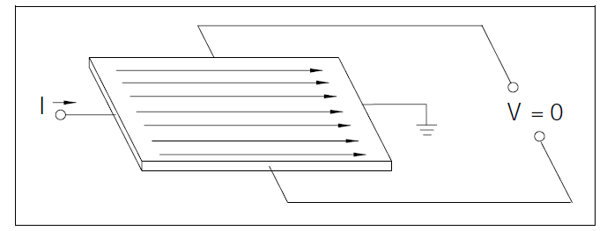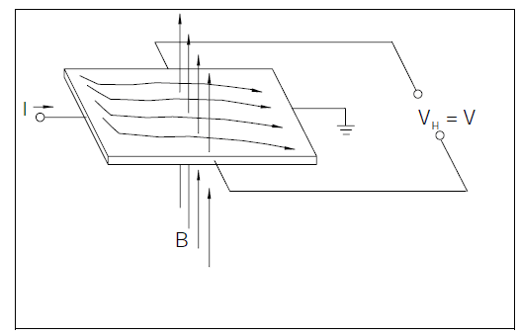
Fig.25. Current Distribution in Hall-Sensor
The Hall voltage is proportional to the vector cross product of the current (I) and the magnetic field (B).
Silicon exhibits the piezoresistance effect, a change in electrical resistance proportional to strain. It is desirable to minimize this effect in a Hall sensor. This is accomplished by orienting the Hall element on the IC to minimize the effect of stress and by using multiple Hall elements. Fig. 25. shows two Hall elements located in close proximity on an IC. They are positioned in this manner so that they may both experience the same packaging stress, represented by R. The first Hall element has its excitation applied along the vertical axis and the second along the horizontal axis. Summing the two outputs eliminates the signal due to stress. MICRO SWITCH Hall ICs use two or four elements.
10.1 Basic Hall Effect Sensors
The Hall element is the basic magnetic field sensor. It requires signal conditioning to make the output usable for most applications. The signal conditioning electronics needed are amplifier stage and temperature compensation. Voltage regulation is needed when operating from an unregulated supply. Fig. 26. illustrates a basic Hall Effect sensor. If the Hall voltage is measured when no magnetic field is present, the output is zero (see Fig. 25). However, if voltage at each output terminal is measured with respect to ground, a non-zero voltage will appear. This is the common mode voltage (CMV), and is the same at each output terminal. It is the potential difference that is zero. The amplifier shown in Fig. 26. must be a differential amplifier so as to amplify only the potential difference – the Hall voltage. The Hall voltage is a low-level signal on the order of 30 microvolts in the presence of a one gauss magnetic field. This low-level output requires an amplifier with low noise, high input impedance and moderate gain. A differential amplifier with these characteristics can be readily integrated with the Hall element using standard bipolar transistor technology. Temperature compensation is also easily integrated. The Hall voltage is a function of the input current. The purpose of the regulator in Fig. 26. is to hold this current constant so that the output of the sensor only reflects the intensity of the magnetic field. As many systems have a regulated supply available, some Hall Effect sensors may not include an internal regulator.
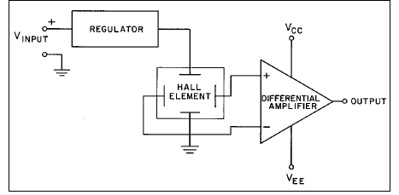
Fig.26. Hall-Effect Sensor with Signal Conditioning
10.2 Digital Output Sensors
This sensor has an output that is just one of two states: ON or OFF. The basic analog output device illustrated in Fig. 27. can be converted into a digital output sensor with the addition of a Schmitt trigger circuit. Fig. 27. illustrates a typical internally regulated digital output Hall effect sensor. The Schmitt trigger compares the output of the differential amplifier (Fig. 23.) with a preset reference. When the amplifier output exceeds the reference, the Schmitt trigger turns on. Conversely, when the output of the amplifier falls below the reference point, the output of the Schmitt trigger turns off.
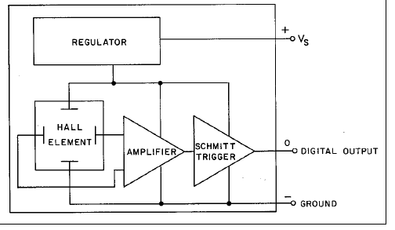
Fig.27. Digital Output Hall-Effect Sensor
10.3 Hall Sensor (TLE4906K)
The TLE4906K and the TLE4906L are integrated circuit Hall-effect sensors designed specifically for highly accurate applications. Precise magnetic switching points and high temperature stability are achieved by active compensation circuits and chopper techniques on chip.
The chopped Hall IC Switch comprises a Hall probe, bias generator, compensation circuits, oscillator and output transistor. The bias generator provides currents for the Hall probe and the active circuits. Compensation circuits stabilize the temperature behaviour and reduce technology variations. The Active Error Compensation rejects offsets in signal stages and the influence of mechanical stress to the Hall probe caused by molding and soldering processes and other thermal stresses in the package. This chopper technique together with the threshold generator and the comparator ensure high accurate magnetic switching points.
Fig.28. Hall-Sensor ICs
10.3.1 Features:
•2.7V to 24V supply voltage
•Operation from unregulated power supply
•High sensitivity and high stability of the magnetic switching points
•High resistance to mechanical stress by Active Error Compensation
•Reverse battery protection (-18V)
•Superior temperature stability
•Peak temperatures up to 195°C without damage
•Low jitter (typ. 1μs)
•High ESD performance (± 6kV HBM)
•Digital output signal
•SMD package SC59 (SOT23 compatible) - (TLE4906K)

11. SIMULATION
For the simulation of the mechanical system in order to check its feasibility, a virtual system was build using “Solidworks 2010” Software. Various components (Mechanical Parts/Structures) of the 90 cc engine were built separately using the software. Then the built parts were assembled into an engine using the software. Then the system was tested using the software for various conditions and test results were obtained which indicated that the system was feasible.
11.1 SOLIDWORKS 2010
SolidWorks is a 3D mechanical CAD (computer-aided design) program that runs on Microsoft Windows and is being developed by Dassault Systèmes SolidWorks Corp., a subsidiary of Dassault Systèmes, S. A. (Vélizy, France).
11.2 MODELLING METHOLOGY
SolidWorks is a Para-solid-based solid modeler, and utilizes a parametric feature-based approach to create models and assemblies.
Parameters refer to constraints whose values determine the shape or geometry of the model or assembly. Parameters can be either numeric parameters, such as line lengths or circle diameters, or geometric parameters, such as tangent, parallel, concentric, horizontal or vertical, etc. Numeric parameters can be associated with each other through the use of relations, which allow them to capture design intent.
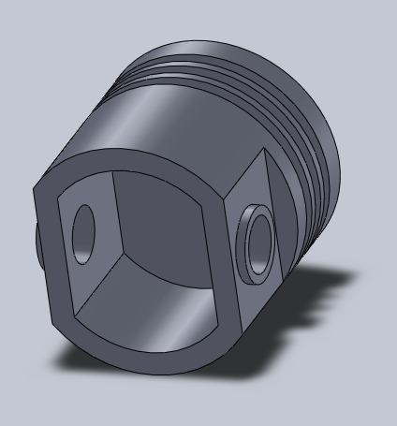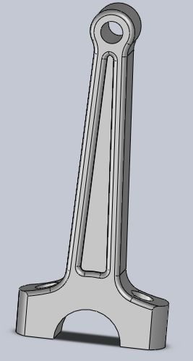
Fig.29. Piston Head modelled using Solidworks Fig.30. Connecting Rod using Solidworks
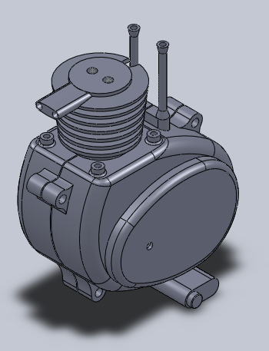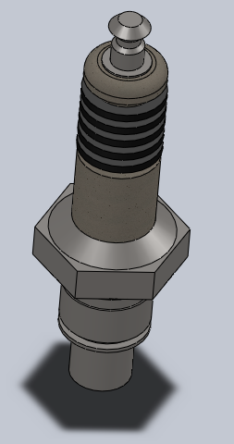
Fig.31. Engine Body Fig.32. Spark Plug
Design intent is how the creator of the part wants it to respond to changes and updates. For example, you would want the hole at the top of a beverage can to stay at the top surface, regardless of the height or size of the can. SolidWorks allows you to specify that the hole is a feature on the top surface, and will then honor your design intent no matter what the height you later gave to the can.
Features refer to the building blocks of the part. They are the shapes and operations that construct the part. Shape-based features typically begin with a 2D or 3D sketch of shapes such as bosses, holes, slots, etc. This shape is then extruded or cut to add or remove material from the part. Operation-based features are not sketch-based, and include features such as fillets, chamfers, shells, applying draft to the faces of a part, etc.
SolidWorks files use the Microsoft Structured Storage file format. This means that there are various files embedded within each SLDDRW (drawing files), SLDPRT (part files), SLDASM (assembly files) file, including preview bitmaps and metadata sub-files. Various third-party tools (see COM Structured storage) can be used to extract these sub-files, although the sub-files in many cases use proprietary binary file formats.
12. MECHANICAL MODEL
The mechanical model of the engine (90 cc, Single Cylinder, Diesel Engine) was prepared in order to simulate the ECCPS system. In the model, for simulating the motion of CRANK, a DC Motor was coupled to it. The movement of the CAM was controlled by the BLDC Motor, which has been coupled to it using Mechanical Coupling (Rigid Coupling). Hence, The CAM Phasing has been completely controlled using ECCPS.
The rpm of the CRANK and CAM of the mechanical model are controlled using the ECCPS system. Their rpm value is serially fed to the PC. The rpm value can be observed using “HyperTerminal” Software.

13. TEST RESULTS
13.1 Test Results of Simulation using SolidWorks
The various parameters of the virtual system were monitored using the SolidWorks 2010 software. The parameters like Angular Velocity, Transmission Displacement and Piston Position were observed in graphical form using the software. The results obtained confirmed that the CRANK & CAM can be practically coupled to the motors and synchronization can be achieved with satisfactory results.
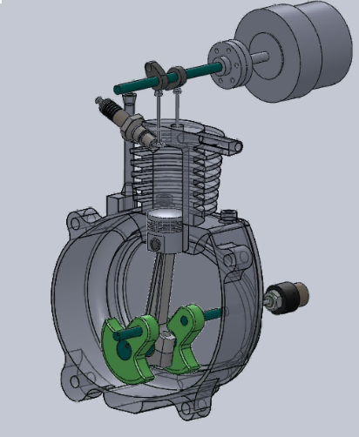
Fig.34. Model of the system in Solidworks
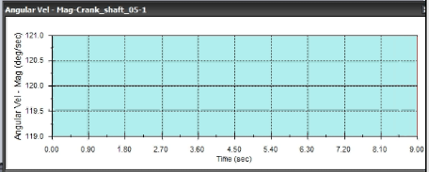
Fig.35. Angular Velocity of the Crankshaft
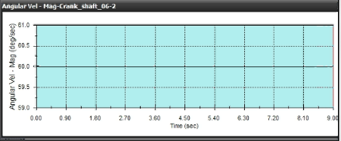
Fig.36. Angular Velocity of the Camshaft
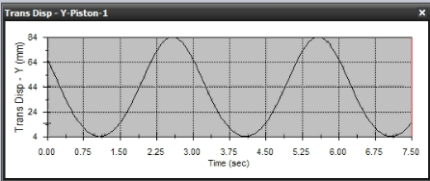
Fig.37. Translational Displacement of the Piston
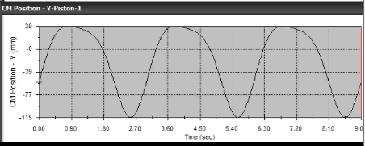
Fig.38. CM Position Displacement of the Piston
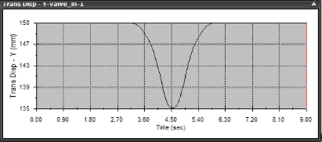
Fig.39. Translational Displacement of the Inlet Valve

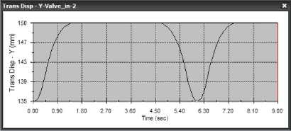
Fig.40. Translational Displacement of the Outlet Valve

13.2 Test Results of Mechanical Model
The ECCPS ensures that the CAM and CRANK are always synchronised with each other and their rpm ratios are maintained as 2:1.
The HyperTerminal window while testing the model is shown in Fig. 40.
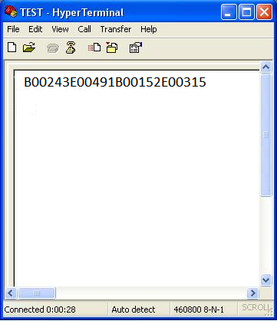
Fig.41. HyperTerminal Window indicating the rpm (B: rpm of BLDC Motor, E: rpm of DC Motor
DISCUSSION
Initially, the feasibility of the system was confirmed by building a virtual model of the system (90 cc, single –cylinder, Diesel engine) in SolidWorks 2010. Then a mechanical model of the system was prepared. In the model, for simulating the motion of CRANK, a DC Motor was coupled to it. The movement of the CAM was controlled by the BLDC Motor, which has been coupled to it using Mechanical Coupling (Rigid Coupling). Hence, The CAM Phasing has been completely controlled using ECCPS.
The Power Supply used has been designed using Bridge rectifiers and Voltage Regulator ICs i.e. 7812 and 7805.
In order to control the motion of the BLDC Motor, the Driver circuit was designed using Power MOSFETs and MOSFET Drivers. IRS2003 MOSFET Driver ICs have been used to energise each pair of MOSFETs. IPB16CN10N Power MOSFETs have been used to supply current pulses to the stator coils of the BLDC Motor.
The BLDC Motor used is a 60Watt, 24V, 1500rpm motor. The DC Motor used is a High Torque, High RPM DC Motor having 500rpm and works on 12V supply voltage.
In order to monitor the rpm of CRANK, Hall-Effect Sensor (TLE4906K) has been used. The rpm of the CAM is monitored by using internal Hall-Effect Sensors of the BLDC Motor.
The test results of the virtual model perfectly match with those of the real-time engine. The motion of CAM and CRANK is synchronized and their rpm ratio is approximately 1:2.
The test results of the mechanical model also satisfy the 1:2 rpm ratio and the synchronization of the CAM and CRANK is observed.
Hence, the synchronization between CRANK and CAM has been achieved by using ECCPS which comprises of the above mentioned components. The advantages of ECCPS phasing method include synchronization between the CAM and the crankshaft (CRANK) with higher precision, meeting the fuel economy standards and emission standards of internal combustion engines, reduction in hydrocarbon and NOx (Nitrogen Oxide and its derivatives) emissions, no mechanical wear and tear, improvement in engine torque leading to efficient performance.
However, the system also has few disadvantages which include requirement of specially designed batteries which can sustain both the vehicle power requirements along with the ECCPS system. Moreover, even though the system is compact, placement of the system in the proximity of the engine may arise some difficulties. All the components utilized for the implementation of the system should essentially be able to withstand high temperatures as the system has to placed in the close vicinity of the engine.

CONCLUSION
This project focuses on the design and implementation of ECCPS system. The results obtained from testing of the system indicate the feasibility of practical implementation of the system into existing vehicles. The components used to implement the ECCPS system include the Hall-Effect sensors (used to sense the position of CRANK and CAM), Automotive-Grade Microcontroller (used to control and monitor the entire system), BLDC Motor, MOSFET bridge driver circuitry to control the motion of BLDC Motor and associated Power Supplies. The system design facilitates easy integration into existing vehicle systems with a minimum of connections to the vehicle. ECCPS vehicle connections are limited to: Battery, CAM and CRANK. As the ECCPS controller contains connections for phase wires and hall sensors of the BLDC Motor, it can be placed remotely from the CAM phasing motor to provide maximum packaging flexibility.
Hence, the synchronization between CRANK and CAM has been achieved by using ECCPS which comprises of the above mentioned components. The advantages of ECCPS phasing method include synchronization between the CAM and the crankshaft (CRANK) with higher precision, meeting the fuel economy standards and emission standards of internal combustion engines, reduction in hydrocarbon and NOx (Nitrogen Oxide and its derivatives) emissions, no mechanical wear and tear, improvement in engine torque leading to efficient performance.

FUTURE WORK
The ECCPS system can be further modified to increase system performance and hence to increase the overall performance of the engine. The following modifications can be done to the system:
The motion of the CRANK can also be controlled by mechanically coupling another BLDC Motor to it which further increases the efficiency of the engine and leads to better engine performance.
- Design of Powerful Batteries which can supply enough power for the starting torque of the BLDC Motors and which can sustain their continuous motion for longer time before recharging them.
- Use of CAN (Controlled Area Network) for transfer of the sensed/monitored data of ECCPS to other systems or for testing and monitoring purposes.
- Implementation of sensor-less BLDC Motor Control System which is based on the principle of Back-EMF. The back-emf can be used to monitor the position of the rotor of the BLDC Motor eliminating the use of Hall-Effect sensors.
The above mentioned modifications can lead to a better ECCPS which is not only efficient but also satisfies the Vehicle Emission Standards and hence environment friendly.

REFERENCES
- Anish Varsani, “Low Cost Brushless DC Motor Controller”, The University of Queensland.
- Geoff Emerson, East Kilbride, “Using the Engine Position (CRANK and CAM) eTPU Functions”, Freescale Semiconductor Application Note, Doc No. AN3769.
- Robert Bosch GmbH, “Magnetic sensors for automotive applications”, ELSEVIER, Sensors and actuators A 91 (2001) 2-6.
- William J. Fleming, “Overview of Automotive Sensors”, IEEE SENSORS JOURNAL, Vol. 1, No. 4, Dec. 2001.
- S.H.Gawande , L.G. Navale, M.R. Nandgaonkar, .D.S. Butala, S. Kunamalla “Identification and Analysis of Engine Speed and Noise in In-line Diesel Engine” ,JJMIE ( Jordan Journal of Mechanical and Industrial Engineering), Vol. 6, No. 1, Feb. 2012, ISSN 1995-6665 .
- Françoise Simonot Lion ,”The design of safe automotive electronic systems” , IES’2006 IEEE Symposium on Industrial Embedded Systems, Antibes Juan-Les-Pins, France ,Oct. 2006.
- Williaam B. Ribbens, “Understanding Automotive Electronics”,Newnes (imprint of ELSEVIER), 6th Ed .
- Gordon Cheever Jr., Charles Sullivan, Karl Schten, Ash Punater, Clinton Erickson, Delphi Automotive,”Design of an Electric Variable CAM Phasor Controller”.
- Deepti.R.Chikkam, “Performance of Disc Brushless DC Motor Applied as Gearless Drive for Wheelchair”.

